The user wants a job that fits to their skills

Can view the details of what the recruiter added in the job description

Needs understanding to use the application

Text processing and recommendation method Content-based filtering

Collaborative filtering Graph-based filtering

Confusion in choosing a right job Similar job alerts for frequent times Many of the jobs are not real

The companies listed do not give their actual structure

Giving incorrect details in profile page No responses for the application

Network problem

The company and the job openings should be verified

User-friendly

Saves lots of time Chat Support

Providing the actual infrastructure of the Industry

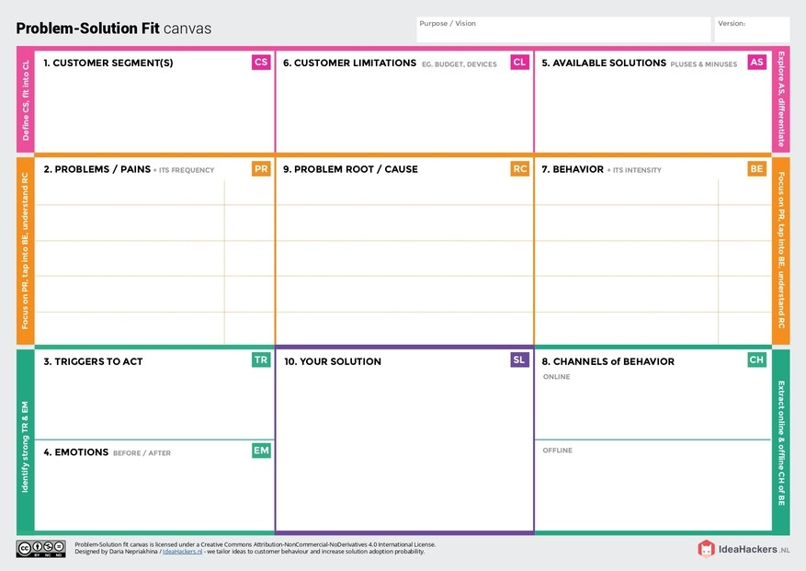The user gets the job alerts

Job description reveals the necessary criteria

Before : Had lots of confusion to choose a job

After : Can attend the job interview without worries

1. Application completion rate
2. Track the percentage of openings filled
3. Providing the actual infrastructure of the Industry
4. By checking and verifying the documents and opening
5. Hybrid filtering technique

Users have to upload their resumes and fill up the essential details such as name, education, skills, location, and experience.

Users can view the job description from their alerts.